Experimental research on mechanical performance of the lightweight composite slabs

Huihui Zou1, Juntao Wang2\*, Xintang Wang3

1Department of Civil Engineering, Ningbo University, Ningbo 315211, China

2Princeton University, Princeton NJ 08544, USA

3The University of Sydney, Sydney, Australia

\*Corresponding author’s e-mail: wxt196322@126.com

**Abstract**. The static mechanical property of a new type of lightweight composite slabs is experimentally studied. The test results show that the composite slab has better entirety and greater bearing capacity, and the restraint at the two ends of the composite slabs has greater effect on bearing capacity of the slabs presented here. It is seen that the failure modes of the composite slab include cracking of concrete and local buckling of the thin-walled steel beams. The results also show that the composite slab works elastically as if the equivalent uniform load applied to the upper surface of the slab is less than 5kN/m2.

**Keywords:**

1. Introduction

To reduce the dead weight of the floor, it can be replaced by ceramsite concrete instead of ordinary concrete with gravel as coarse aggregate to form profiled steel plate - lightweight aggregate concrete composite floor [1-2]. The light steel truss-profiled steel sheet concrete composite floor was presented and the mechanical performance of it has been experimentally studied, and the combined action of the light steel trusses and the lightweight aggregate concrete has been studied [3], however the lightweight precast concrete panels was not considered in the paper. The laminated composite floor was studied [4], in which the occlusal effect between the upper laminated plates and precast panel was discussed to obtain the effective construction. Based on the existing papers, mechanical property of thin-walled steel truss-ceramsite concrete composite slabs was studied [5], in which the thin-walled steel truss as bearing beam was considered, but there were still some deficiencies for engineering application.

It follows that research on the lightweight prefabricated composite floor needs to be further studied. Hence, the lightweight composite slab was put forward, which consists of H-type thin-walled steel beams and lightweight concrete including the precast panels and the post-pouring layer. The composite slabs also have advantages of no formwork support, being lighter weight and factory prefabrication, et al.

1. Dimensions of specimens

It is noted that the main steel beams of three specimens are supported at the support beam as shown in Figure 1. Each secondary beam (steel channel) is connected with main steel beam and the support beam. The mechanical properties of the materials used are taken as: yield strength and elastic modulus of steel are fy=146MPa, Es=2.06×105MPa, respectively, and cube strength standard value and elastic modulus of lightweight concrete are $σ_{c}=41.2MPa$ and Ec=2.17×104MPa, respectively.

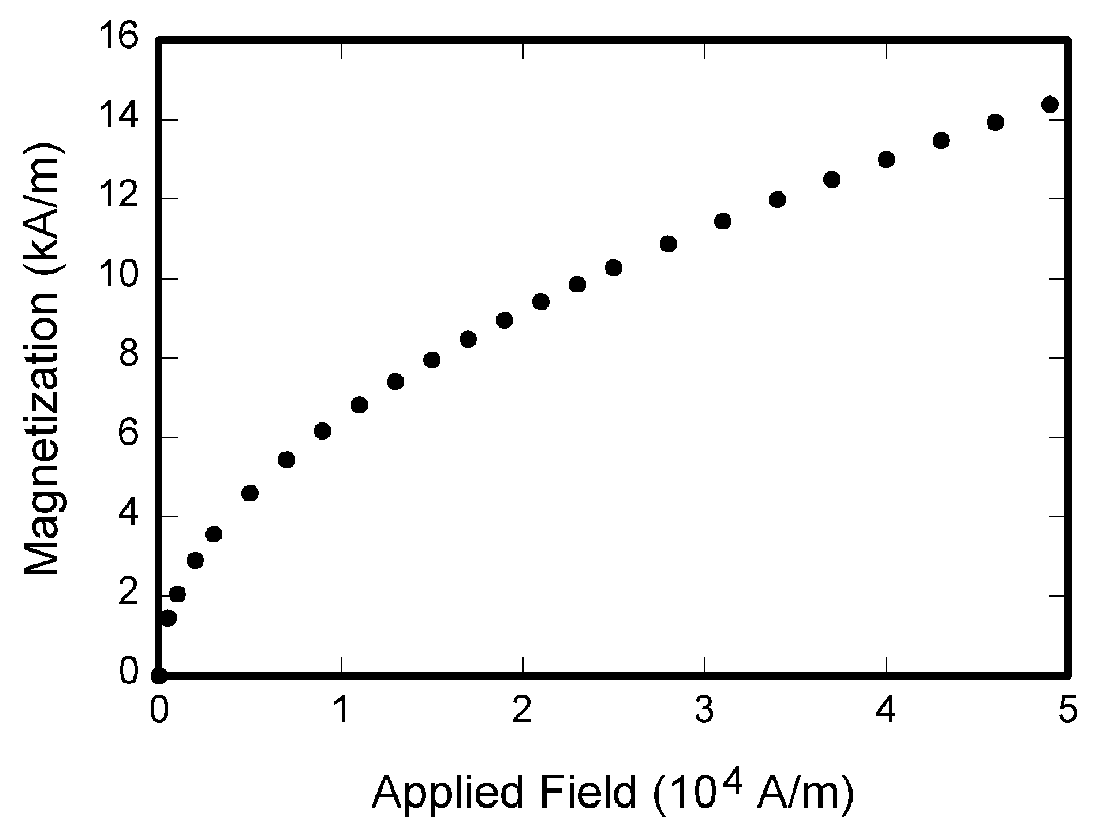

**Figure 1.** Construction and geometrical dimensions of specimens.

It is also seen that the specimen SJ1 has the largest deformation, and the maximum deflection of the specimen is up to 16mm, which shows the better plastic deformation ability of the slab. It is also seen that the specimen SJ1 has the largest deformation, and the maximum deflection of the specimen is up to 16mm, which shows the better plastic deformation ability of the slab. It is also seen that the specimen SJ1 has the largest deformation, and the maximum deflection of the specimen is up to 16mm, which shows the better plastic deformation ability of the slab.

The composite slabs also have advantages of no formwork support, For application of the slabs in engineering, the mechanical properties of it is studied on basis of experiments. The composite slabs also have advantages of no formwork support, For application of the slabs in engineering, the mechanical properties of it is studied on basis of experiments, The composite slabs also have advantages of no formwork support, For application of the slabs in engineering, the mechanical properties of it is studied on basis of experiments, The composite slabs also have advantages of no formwork support, For application of the slabs in engineering, the mechanical properties of it is studied on basis of experiments, The composite slabs also have advantages of no formwork support, For application of the slabs in engineering, the mechanical properties of it is studied on basis of experiments.

* It is studied on basis of experiments.
* It is studied on basis of experiments, it is studied on basis of experiments.
* It is studied on basis of experiments, it is studied on basis of experiments.

## Specimens results

It is also seen that the specimen SJ1 has the largest deformation, and the maximum deflection of the specimen is up to 16mm, which shows the better plastic deformation ability of the slab. It is also seen that the specimen SJ1 has the largest deformation, and the maximum deflection of the specimen is up to 16mm, which shows the better plastic deformation ability of the slab. It is also seen that the specimen SJ1 has the largest deformation, and the maximum deflection of the specimen is up to 16mm, which shows the better plastic deformation ability of the slab.

By derivative of equtions (1) - (2) with respect to time t, we can obtain

 (1)

 (2)

It is especially noted that the geometrical dimensions of cross-section of the thin-walled steel beams, steel channels and dimensions of the precast panels are shown in Figure 2. It is seen that the thickness of steel plate of the main steel beams and the steel channels is 0.6mm, and thickness of the precast panels is 40mm, and depth of groove of the precast panel is 10mm. Each secondary beam (steel channel) is connected with main steel beam and the support beam. Each secondary beam (steel channel) is connected with main steel beam and the support beam.

|  |  |
| --- | --- |
| IMG_20150707_103735 |  |
| (a) | (b) |

**Figure 2**. Failure characteristics of specimen SJ1.

A A A A A A A A A A A A A A A A A A A A, A A A A A A A A A A A A A A A A A A A A, A A A A A A A A A A A A A A A A A A A A, A A A A A A A A A A A A A A A A A A A A, A A A A A A A A A A A A A A A A A A A A, A A A A A A A A A A A A A A A A A A A A, A A A A A A A A A A A A A A A A A A A A.

* + 1. Test phenomena. The specimens are denoted as SJ1, SJ2 and SJ3, for which the constraint conditions for them are different. In particularly, two ends of the main steel beams of specimens SJ1 and SJ2 are all simply supported, and four corners of specimen SJ2 are restrained in vertical direction, however two ends of the main steel beam of specimen SJ3 are fixed support. All the other parameters of three specimens are the same with each other as shown above. As shown in Table 1.

|  |  |  |  |  |
| --- | --- | --- | --- | --- |
| **Table 1.** A table with headings spanning two columns and containing notesa. | | | | |
| Nucleus | Thickness  (mg cm–2) | Composition | Separation energies | |
| , n (MeV) | , 2n (MeV) |
| 181Ta | 19.3±0.1b | Natural | 7.6 | 14.2 |
| 208Pb | 3.8±0.8c | 99% enriched | 7.4 | 14.1 |
| 209Bi | 2.6±0.01c | Natural | 7.5 | 14.4 |
| a Notes are referenced using alpha superscripts.  b Self-supporting.  c Deposited over Al backing. | | | | |

It is also seen that the specimen SJ1 has the largest deformation, and the maximum deflection of the specimen is up to 16mm, which shows the better plastic deformation ability of the slab. It is also seen that the specimen SJ1 has the largest deformation, and the maximum deflection of the specimen is up to 16mm, which shows the better plastic deformation ability of the slab. It is also seen that the specimen SJ1 has the largest deformation, and the maximum deflection of the specimen is up to 16mm, which shows the better plastic deformation ability of the slab.

It is also seen that the specimen SJ1 has the largest deformation, and the maximum deflection of the specimen is up to 16mm, which shows the better plastic deformation ability of the slab. It is also seen that the specimen SJ1 has the largest deformation, and the maximum deflection of the specimen is up to 16mm, which shows the better plastic deformation ability of the slab. It is also seen that the specimen SJ1 has the largest deformation, and the maximum deflection of the specimen is up to 16mm, which shows the better plastic deformation ability of the slab.

* + 1. Notes. It is seen from the results shown in Figure 2 that the relative horizontal displacements at hinged-fixed end of specimens are all smaller, and the slip of specimen SJ1 was the lest and specimen SJ3 the largest, which means that the relative displacement of steel beam and concrete panel of the specimen with the fixed support condition at two ends is larger. As shown in table 2 and table 3.

|  |  |  |  |  |  |  |
| --- | --- | --- | --- | --- | --- | --- |
| **Table 2.** A slightly more complex table with a caption that is the same width as the table. Simply place the caption inside a row at the top of the table and merge (combine) the cells together so that you have a single table cell the width of the table. Justify the caption. | | | | | | |
|  | Wake Chi Sqr. (*N*=15, *df*=1) | *p* | Stage 1 Chi Sqr. (*N*=15, *df*=1) | p | Stage 2 Chi Sqr. (*N*=15, *df*=1) | *p* |
| **F3** | 1.143 | 0.285 | 0.286 | 0.593 | 0.286 | 0.593 |
| **Fz** | 1.143 | 0.285 | 0.067 | 0.796 | 0.067 | 0.796 |
| **Cz** | 1.143 | 0.285 | 0.077 | 0.782 | 0.286 | 0.593 |

1. Conclusion

Based on the results and discussions presented above, the conclusions are obtained as below:

(1) It is shown that all the lightweight aggregate concrete composite slabs have better plastic deformation ability and higher bearing capacity, and the ultimate elastic bearing load is 7.5kN/m2, which is much greater than the normal service load of 2kN/m2.

(2) The failure forms of the composite slabs involve local buckling of the thin-wall steel beams, overall torsion of the steel beams and through cracks on top surface and lower surface of concrete panel.

(3) It is concluded that the boundary conditions at ends of the specimens has great effect on static mechanical properties of the composite slabs presented here, and the composite slab with restraint at four corners has the largest bearing capacity.

Acknowledgments

This work was financially supported by the A A A A A A A A A A A A A A A A A A A A A. (XXXXXXX).

References

1. Van der Geer J, Hanraads J A J and Lupton R A (2010) The art of writing a scientific article. J. Sci. Commun., 163: 51–59.
2. Podani J (1994) Multivariate Data Analysis in Ecology and Systematics. SPB Publishing, The Hague.
3. Mettam G R and Adams, L B (2009) How to prepare an electronic version of your article. In: Jones B S and Smith R Z (Eds.), *Introduction to the Electronic Age*. E-Publishing Inc., New York. pp. 281-304.
4. Thompson J N (1984) Insect Diversity and the Trophic Structure of Communities. In: Ecological Entomology. New York. pp. 165-178.
5. Cancer Research UK. (1975) Cancer statistics reports for UK. http://www.cancerreseark.org/aboutcancer/statistics.